Jahnvi Pael

2024-01-23

library(dplyr)

library(ggplot2)  
library(randomForest)

library(corrplot)

library(psych)

# Load train and test datasets  
train_data <- read.csv("adm_train.csv")  
test_data <- read.csv("adm_test.csv")

# Explore the data  
str(train_data)

## 'data.frame': 249 obs. of 9 variables:  
## $ Serial.No. : int 1 2 3 4 5 6 7 8 9 10 ...  
## $ GRE.Score : int 337 324 316 322 314 330 321 308 302 323 ...  
## $ TOEFL.Score : int 118 107 104 110 103 115 109 101 102 108 ...  
## $ University.Rating: int 4 4 3 3 2 5 3 2 1 3 ...  
## $ SOP : num 4.5 4 3 3.5 2 4.5 3 3 2 3.5 ...  
## $ LOR : num 4.5 4.5 3.5 2.5 3 3 4 4 1.5 3 ...  
## $ CGPA : num 9.65 8.87 8 8.67 8.21 9.34 8.2 7.9 8 8.6 ...  
## $ Research : int 1 1 1 1 0 1 1 0 0 0 ...  
## $ Chance.of.Admit : num 0.92 0.76 0.72 0.8 0.65 0.9 0.75 0.68 0.5 0.45 ...

summary(train_data)

## Serial.No. GRE.Score TOEFL.Score University.Rating SOP   
## Min. : 1 Min. :290.0 Min. : 93.0 Min. :1.000 Min. :1.00   
## 1st Qu.: 63 1st Qu.:310.0 1st Qu.:104.0 1st Qu.:2.000 1st Qu.:3.00   
## Median :125 Median :318.0 Median :108.0 Median :3.000 Median :3.50   
## Mean :125 Mean :317.6 Mean :108.3 Mean :3.249 Mean :3.54   
## 3rd Qu.:187 3rd Qu.:326.0 3rd Qu.:112.0 3rd Qu.:4.000 3rd Qu.:4.50   
## Max. :249 Max. :340.0 Max. :120.0 Max. :5.000 Max. :5.00   
## LOR CGPA Research Chance.of.Admit   
## Min. :1.500 Min. :6.800 Min. :0.0000 Min. :0.3400   
## 1st Qu.:3.000 1st Qu.:8.200 1st Qu.:0.0000 1st Qu.:0.6400   
## Median :3.500 Median :8.640 Median :1.0000 Median :0.7300   
## Mean :3.546 Mean :8.641 Mean :0.5582 Mean :0.7284   
## 3rd Qu.:4.000 3rd Qu.:9.100 3rd Qu.:1.0000 3rd Qu.:0.8500   
## Max. :5.000 Max. :9.920 Max. :1.0000 Max. :0.9700

# Renamed columns  
colnames(train_data) <- c("Serial No", "GRE", "TOEFL", "University Rating", "SOP", "LOR", "CGPA", "Research", "Chance of Admit")  
colnames(test_data) <- c("Serial No", "GRE", "TOEFL", "University Rating", "SOP", "LOR", "CGPA", "Research", "Chance of Admit")

any_missing_train <- any(is.na(train_data)) # there are no missing values in the entire train_data data set.  
any_missing_test <- any(is.na(test_data)) # there are no missing values in the entire test_data data set.

# Detecting Outliers  
# Boxplot for Score  
boxplot(train_data$GRE, main = "Boxplot of GRE")

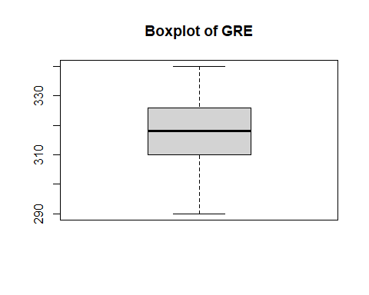

boxplot(train_data$TOEFL, main = "Boxplot of TOEFL")

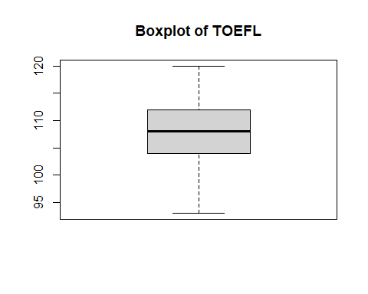

boxplot(train_data$CGPA, main = "Boxplot of CGPA")

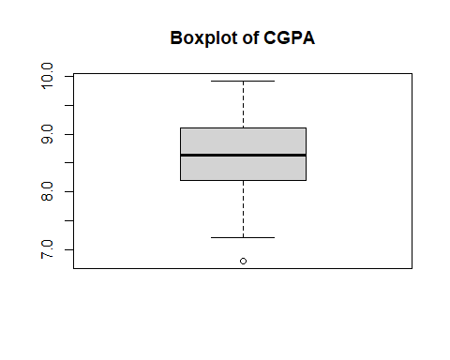

# Identifying outliers using z-score  
z_scores <- scale(train_data$CGPA)  
outliersCGPA <- which(abs(z_scores) > 3) # outlier detected at 59

# Imputed outlier with the median of CGPA directly in the same column  
train_data$CGPA[abs(z_scores) > 3] <- median(train_data$CGPA, na.rm = TRUE)

#Checking Data Distribution  
# Histogram   
hist(train_data$CGPA, main = "Histogram of CGPA", col = "lightblue")

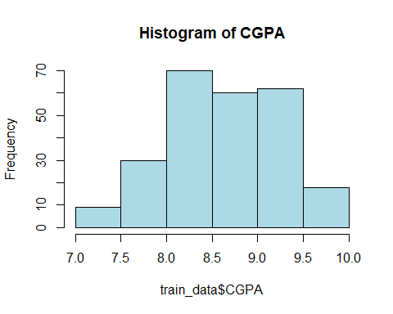

hist(train_data$GRE, main = "Histogram of GRE", col = "blue")

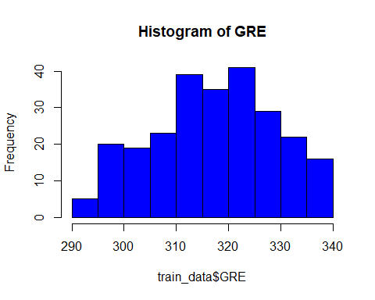

hist(train_data$TOEFL, main = "Histogram of TOEFL", col = "green") # doesn't feel like data is highly skewed.

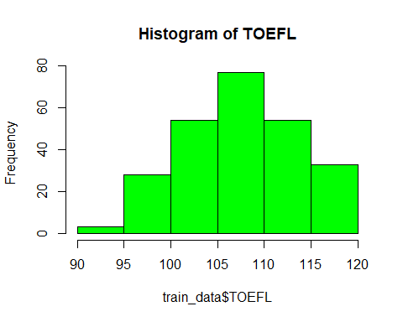

# Visualizing Correlations  
# Correlation matrix  
train_correlation_matrix <- cor(train_data[, c("GRE", "TOEFL", "CGPA", "Research", "Chance of Admit")])

# Create a heatmap using corrplot  
corrplot(train_correlation_matrix, method = "number", col = colorRampPalette(c("white", "blue", "red"))(100), number.cex = 0.7) # This approach can be helpful when the color differences are not very pronounced

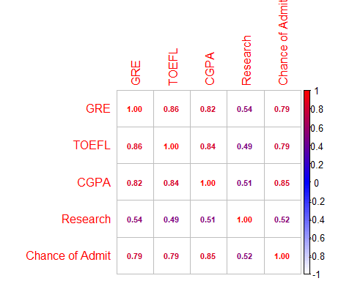

# Multiple correlations using the psych package  
pairs.panels(train_data[, c("GRE", "TOEFL", "CGPA")])

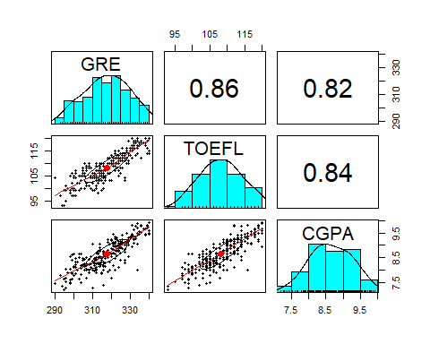

# Scatter plot of GRE vs. CGPA  
library(ggplot2)  
ggplot(train_data, aes(x = GRE, y = CGPA, color = `Chance of Admit`)) +  
 geom_point() +  
 geom_smooth(method = "lm", se = FALSE, color = "blue") +  
 labs(title = "Scatter Plot of GRE vs. CGPA") +  
 scale_color_gradient(low = "blue", high = "red")

## `geom_smooth()` using formula = 'y ~ x'

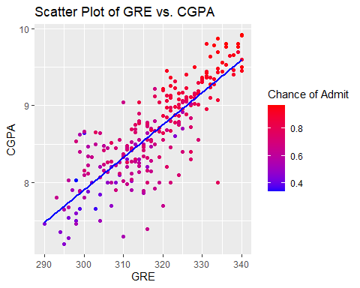

# Scatter Plot of TOEFL vs. CGPA  
ggplot(train_data, aes(x = TOEFL, y = CGPA, color = `Chance of Admit`)) +  
 geom_point() +  
 geom_smooth(method = "lm", se = FALSE, color = "blue") +  
 labs(title = "Scatter Plot of TOEFL vs. CGPA") +  
 scale_color_gradient(low = "blue", high = "red")

## `geom_smooth()` using formula = 'y ~ x'

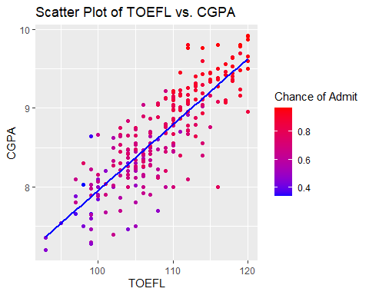

# Scatter Plot of GRE vs. TOEFL  
ggplot(train_data, aes(x = GRE, y = TOEFL, color = `Chance of Admit`)) +  
 geom_point() +  
 geom_smooth(method = "lm", se = FALSE, color = "blue") +  
 labs(title = "Scatter Plot of GRE vs. TOEFL") +  
 scale_color_gradient(low = "blue", high = "red")

## `geom_smooth()` using formula = 'y ~ x'

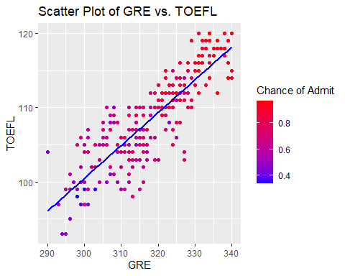

# Random Forest  
model_rf <- randomForest(`Chance of Admit` ~ GRE + TOEFL + LOR + CGPA + Research, data = train_data)

# Make predictions on test_data  
predictions_rf <- predict(model_rf, newdata = test_data)

# Evaluating the model   
mse_rf <- mean((test_data$`Chance of Admit` - predictions_rf)^2)  
mae_rf <- mean(abs(test_data$`Chance of Admit` - predictions_rf))  
r_squared_rf <- 1 - (sum((test_data$`Chance of Admit` - predictions_rf)^2) / sum((test_data$`Chance of Admit` - mean(test_data$`Chance of Admit`))^2))  
rmse_rf <- sqrt(mean((test_data$`Chance of Admit` - predictions_rf)^2))

# Saved predictions to a CSV file  
predictions_df <- data.frame(`Chance of Admit Predicted` = predictions_rf)  
write.csv(predictions_df, "predicted_results_RF.csv", row.names = FALSE)

# use the metrics as needed  
print(paste("MSE:", mse_rf))

## [1] "MSE: 0.00348359269144187"

print(paste("MAE:", mae_rf))

## [1] "MAE: 0.0453968875712672"

print(paste("R-squared:", r_squared_rf))

## [1] "R-squared: 0.798016829708392"

print(paste("RMSE:", rmse_rf))

## [1] "RMSE: 0.0590219678716482"

The performance metrics I’ve obtained for my Random Forest regression model are as follows:

MSE: 0.0035

Lower MSE values are desirable, and in this case, a MSE of 0.0035 suggests that, on average, the squared difference between the predicted and actual Chance of Admit values is relatively small. This indicates good predictive accuracy.

MAE: 0.0455

The MAE measures the average absolute difference between predicted and actual values. An MAE of 0.0455 means, on average, the model's predictions deviate by approximately 0.0455 from the actual values. This value is relatively small, indicating good accuracy.

R-squared: 0.7971

R-squared is a measure of how well the model explains the variance in the target variable. An R-squared of 0.7971 indicates that about 79.71% of the variance in the Chance of Admit is explained by the model. This is a good R-squared value, suggesting that the model captures a substantial portion of the variability in the target variable.

RMSE: 0.0592

RMSE is the square root of the MSE and provides a measure of the average magnitude of errors. An RMSE of 0.0592 suggests that, on average, the model's predictions deviate by approximately 0.0592 from the actual values. This value is relatively small, indicating good accuracy.

In summary, based on the provided metrics, your Random Forest regression model seems to be performing well on the test dataset. The small values of MSE, MAE, and RMSE, along with the relatively high R-squared, suggest that the model provides accurate predictions for the Chance of Admit.